# **Tables**

# **Scatter Plot**

## **0-Keys**

Simple scatter plot

Bubble chart 🡪 extended variant of scatter plot.

Uses

## **1-Key and 2-Keys**

With ordering [Not alphabetical, but ordered with total arrest]

The bar-chart is ordered according to the same attribute that we are using to encode the length of the bars.   
Comparisons can be made easily because the base-line for all these bars are same.  
We are making an aligned spatial position comparison.

Without ordering (Here it is alphabetically ordered)

What is the 4th highest, 7th lowest ?

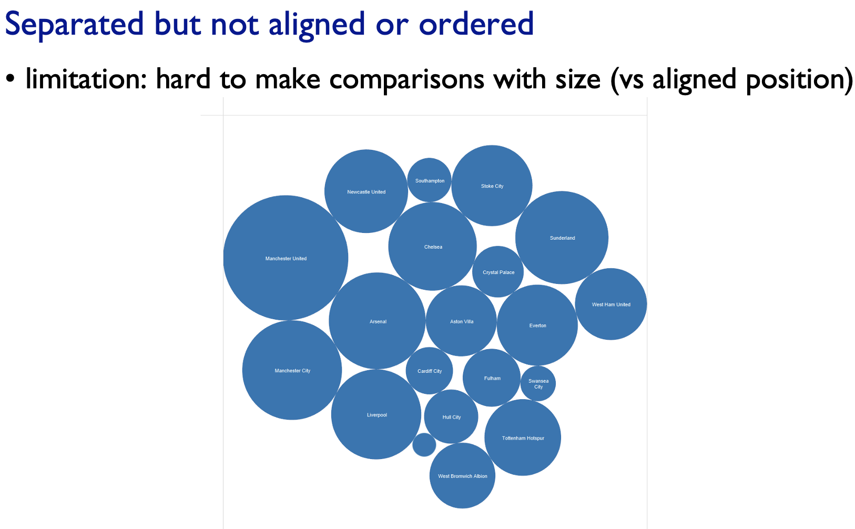Yet we can find the biggest and smallest, but it is much hard to make the find grain comparisons of size with these circles than it was those aligned length (ordered bar-chart).

# **Bar Chart**

For that quantitative attribute 🡪 we can make a very-very small fine grained spatial comparisons between those bar heights

## **Stacked Bar Chart**

The second categorical attribute(stacked key attribute or glyphs) is used to divide up again the spatial regions.  
We now have a vertical stack of line marks. For each one of these we just don’t have a single mark, we have composite objects where we have multiple marks that are aligned. 🡪 glyph

We have a lined comparison of only certain things   
 🡪 we have it for the entire glyph.  
 🡪 we have it for the low component. (Red component in the bottom)  
But we have un-aligned comparisons for the green and blue segments.

So high precision 🡪 aligned  
 low precision 🡪 un-alligned

There is a part-to-whole relationship.

There can be many key attributes in the bar chart,  
But we cannot visualize more than 10 segments in the stack.

## **Stream Graph**

This is a box-office data, where the profit will be more initially and flattens out, and then increases at the end (100th day like that)

# **Dot / Line Chart**

